13
Neural Networks for Crop Disease Detection

Mohammad Ubaidullah Bokhari, Gaurav Yadav, and Md. Zeyauddin
Aligarh Muslim University, Aligarh, India

13.1 INTRODUCTION
Crop diseases represent a critical and pervasive challenge that has far- reaching implications for food production on a global scale. As the world’s population continues to burgeon, the demand for food surges in tandem, necessitating increased agricultural output. However, the insidious threat of crop diseases looms large, consistently undermining efforts to ensure food security. These diseases are a formidable adversary, capable of caus- ing substantial yield losses, reduced crop quality, and economic devasta- tion for farmers and nations alike. They strike indiscriminately, affecting a wide array of crops, from staple grains like rice, wheat, and corn to cash crops such as coffee and cocoa. The consequences of unchecked crop dis- eases ripple throughout the food supply chain, from reduced crop avail- ability and increased food prices to potential food shortages in vulnerable regions. In a world already grappling with the multifaceted challenges of climate change, resource scarcity, and environmental degradation, the impact of crop diseases exacerbates an already precarious situation. Figure
  - illustrates the role of artificial intelligence (AI) in agriculture [1].
In this context, the need for rapid and accurate disease detection in agri- culture becomes abundantly clear. Traditional methods of disease identi- fication, reliant on human observation and often requiring laboratory testing, are time-consuming and resource-intensive. By the time a disease outbreak is confirmed, it may have already wrought significant damage.

DOI: 10.1201/9781003485179-13 227

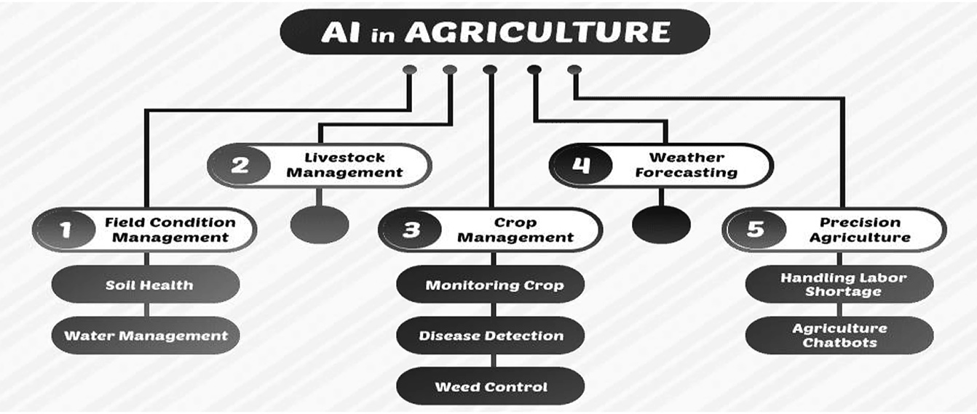

FIGURE 13.1
Role of AI in agriculture.

This lag in detection can hamper the effectiveness of disease management strategies and result in preventable losses. Rapid and accurate disease detection, facilitated by advanced technologies such as AI and remote sensing, offers a transformative solution to this pressing challenge. These technologies empower farmers with the ability to swiftly identify and respond to disease outbreaks, allowing for timely interventions like tar- geted pesticide application or crop rotation. Furthermore, accurate dis- ease detection enables precision agriculture practices, minimising the unnecessary use of resources and reducing the environmental footprint of agriculture.

INTRODUCTION OF NEURAL NETWORK
A “neural network” is a kind of computer model that mimics the design and functionality of biological neural networks, such as the human brain. It is composed of neurons, which are interconnected processing units that work together to evaluate data and create judgements. Neural networks have found significant use in a variety of machine learning and AI appli- cations, including image recognition, natural language processing, and others. The same can be understood from the illustration in Figure 13.2. Here are a few kinds of neural networks that are described in depth with illustrations:

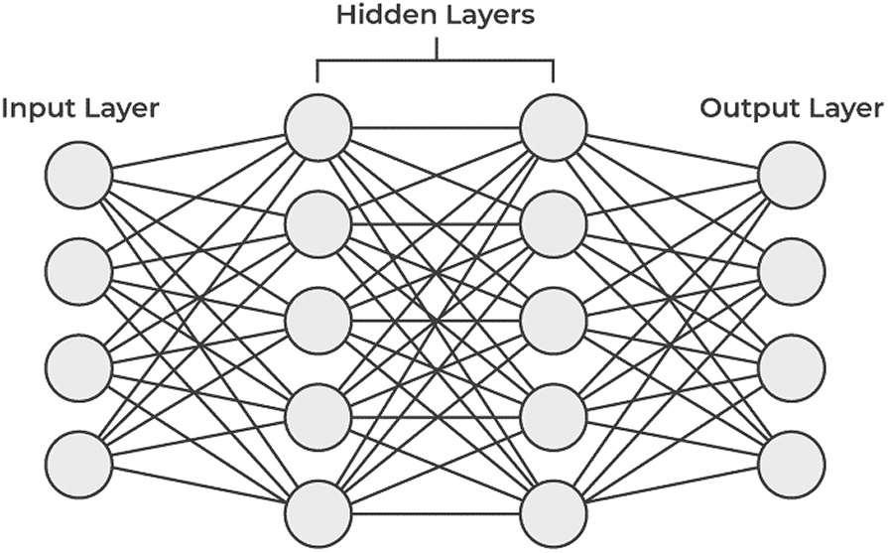

FIGURE 13.2
Working of neural network [1].

    - Feedforward Neural Network (FNN): This kind of neural network is the simplest since there are no feedback loops, and information just travels in one way from the input layer to the output layer. As an example, binary classification tasks like email spam detection may be performed with a simple FNN. Email characteristics are received by the input layer; hidden levels analyse them, and the output layer determines whether or not the email is spam.
      - FNNs are the most basic form of neural networks.
      - They are made up of an input layer, one or more hidden layers, and an output layer.
      - Information passes through them in a single path, from the input layer through the hidden layers to the output layer.
      - Commonly used for regression and classification tasks.
    - CNNs (Convolutional Neural Networks) are created specifically for image-processing jobs. To automatically extract hierarchi- cal information from input photos, they use convolutional layers. Illustration: A CNN may be used to recognise objects in photos, like as cats or dogs, in image categorisation. Figure 13.3 shows the architecture of CNN.
      - Convolutional layers are used by CNNs to automatically learn spa- tial hierarchies of features.
      - They analyse grid-like input, such as photos and movies.
      - CNNs have been highly successful in image recognition tasks.
    - Recurrent Neural Network (RNN): RNNs are used to process sequential data, and they feature feedback loops that let data flow

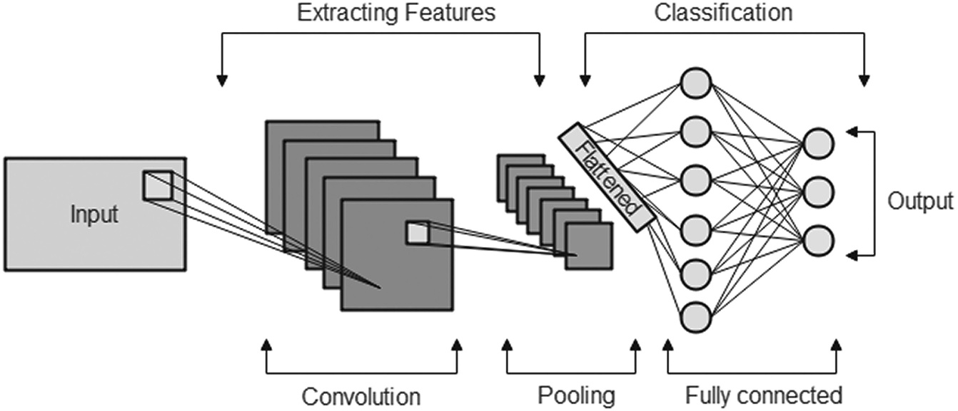

FIGURE 13.3
CNN architecture [1].
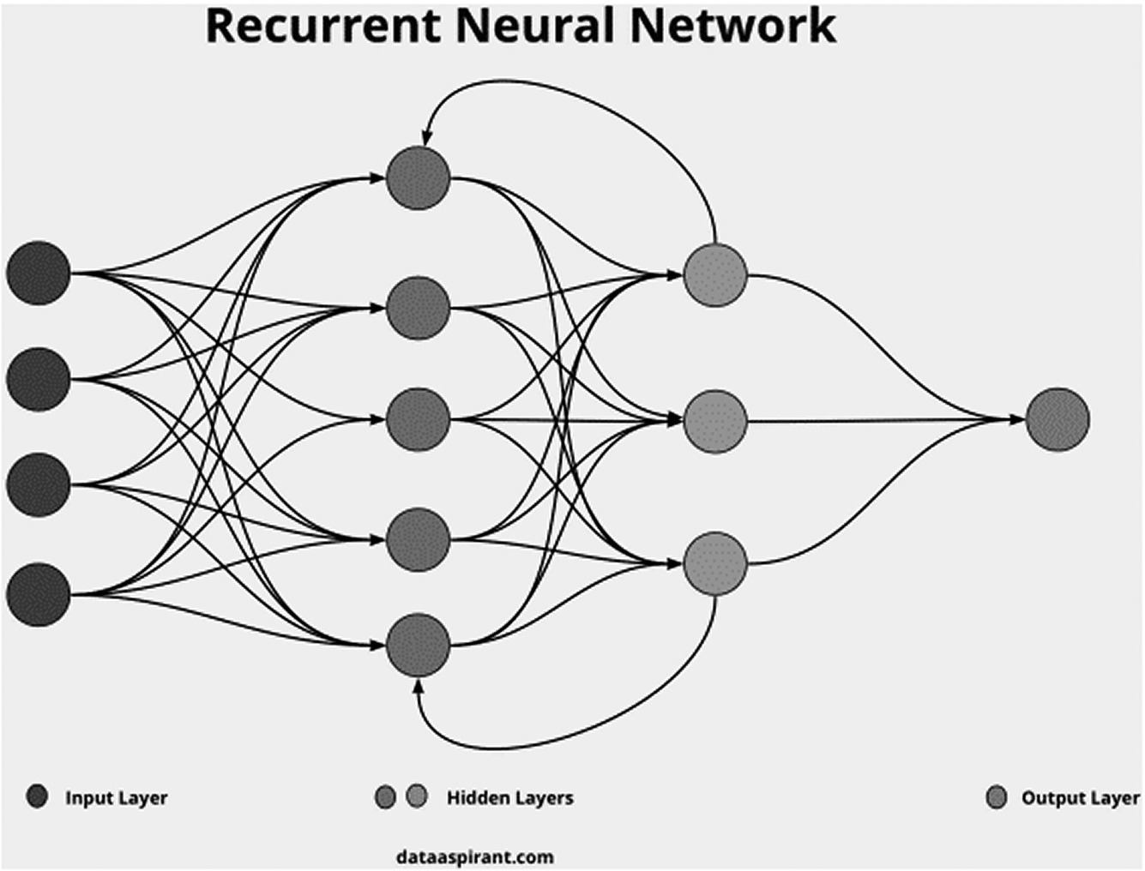

FIGURE 13.4
RNN neural network [2].

from one stage in the sequence to the next. Illustration: Because RNNs can preserve context between words in a phrase, they are advantageous for tasks involving natural language processing, including text creation, machine translation, and sentiment analy- sis. Figure 13.4 shows the architecture of RNN.

      - RNNs include recurrent connections, which enable information to be transmitted from one step in the sequence to the next.
      - They are specialised for sequential data, such as time series or nat- ural language.
      - RNNs are used in tasks like text generation, speech recognition, and machine translation.
    - Long Short-Term Memory Network (LSTM): LSTMs are a spe- cific kind of RNN designed to deal with the vanishing gradient issue. For modelling sequences with long-term dependencies, they work especially well. Illustration: Speech recognition systems may employ LSTMs to translate audio input into text. Figure 13.5 shows the architecture of LSTM.
      - Long sequences are a good fit for LSTMs, a kind of RNN that solves the vanishing gradient issue.
      - They are better suited to handle context because they contain memory cells that can store and retrieve information over lengthy sequences.
      - LSTMs are commonly used in speech recognition, text generation, and language modelling.
    - Gated Recurrent Unit (GRU): GRUs, which are computationally more effective than LSTMs, are intended to capture long-term rela- tionships in sequential data. GRUs can recognise patterns and events in video streams and are utilised in applications like video analysis.
      - GRUs are another type of RNN similar to LSTMs but with a sim- plified architecture.
      - They have fewer parameters and are often faster to train than LSTMs while performing similarly in many tasks.

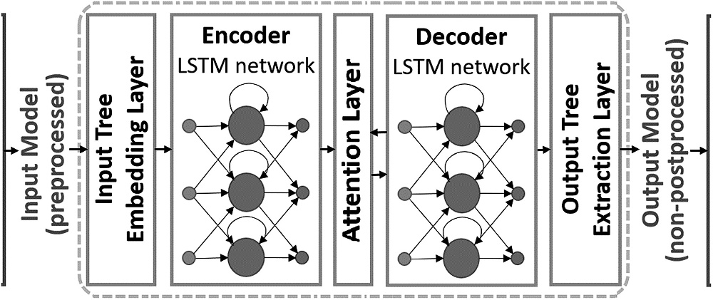
FIGURE 13.5
LSTM neural network [3].

    - Auto-Encoder: This kind of neural network is utilised for dimen- sionality reduction and unsupervised learning. They are made up of a decoder and an encoder. As an example, auto-encoders may be trained to reflect typical data patterns for anomaly identification. Any departure from the established trends can be an abnormality.
      - A decoder reconstructs the input from the encoding, whereas an encoder translates input data to a lower-dimensional representa- tion (encoding).
      - Auto-encoders are employed for unsupervised learning and fea- ture learning.
      - Data compression, denoising, and anomaly detection are used for auto-encoders.
    - GAN (Generative Adversarial Network): A discriminator and a generator are the two neural networks that make up GANs, and they are in competition with one another. The generator creates imaginary data, while the discriminator tries to distinguish between real and fake data. In Figure 13.6, GANs are used in the creation of realistic-appearing pictures, as well as in the transfer of creative styles from one image to another.
      - GANs are composed of two adversarial-trained neural networks: a discriminator and a generator.
      - The generator produces fake data, while the discriminator attempts to tell the difference between actual and fake data.
      - Realistic photos, movies, and other sorts of data may be produced with GANs.

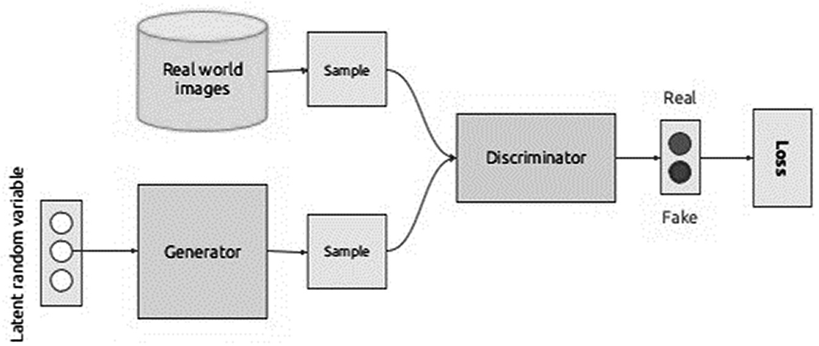
FIGURE 13.6
GAN neural network [4].

The neural network designs that follow are but a few examples. Because of their tremendous adaptability, neural networks may be trained on the right kinds of data and used for a wide range of tasks and domains.

CONTEMPORARY SCENARIO OF NEURAL NETWORK IN CROP DETECTION
The contemporary scenario of neural networks in crop detection represents a ground-breaking convergence of technology and agriculture, addressing the ever-increasing demand for sustainable food production in the face of mounting global challenges. Previous research in this field has paved the way for transformative developments. For instance, CNNs have emerged as a game-changer in crop disease detection. These deep-learning models have demonstrated remarkable prowess in recognising subtle visual cues and patterns associated with various crop diseases. By analysing images of leaves, fruits, or entire crops, CNNs can swiftly and accurately iden- tify signs of infection or stress, enabling timely intervention and reducing crop losses. Moreover, recurrent neural networks (RNNs) and their vari- ants have proven instrumental in time-series data analysis, essential for monitoring crop health over extended periods. They have been applied in predicting disease outbreaks based on historical weather and disease incidence data, aiding farmers in optimising their disease management strategies. Additionally, GANs have revolutionised the generation of syn- thetic crop disease images, which, when combined with real data, enhance the robustness of neural network models by exposing them to a broader spectrum of disease manifestations. There are several researchers who have done lots of work in the field of crop disease detection in the field of AI, including machine learning, deep learning, and neural networks. For instance, a study by Shahi et al. [5] intended to analyse current develop- ments in agricultural disease diagnosis with a focus on machine learning and deep-learning methods employing unmanned aerial vehicles (UAV) based remote sensing. First, we discuss how various sensors and image- processing methods are essential for enhancing crop disease detection using UAV data. The second thing we suggest is a taxonomy for compil- ing and classifying the research already done on agricultural disease iden- tification using UAV photography. The effectiveness of several machine learning and deep-learning techniques for agricultural disease detection

is then investigated and summarised. Finally, we highlight the difficulties, prospects, and future research areas of UAV-based remote sensing for agri- cultural disease identification. In a study, Putra et al. [6] suggested a trans- fer learning-based approach to dealing with such problems. Our process involves multiple phases. The rice leaf is preprocessed in the first phase. Second, balanced class weighting was used owing to the imbalance in the data. Third, three layers of convolution were added to the transfer learning model to enhance the network performance. Using a bandit-based tech- nique, the parameters of fully linked layers were optimised. The leaf was divided into nine groups in the final stage. We contrast our approach with the most recent state of the art (SOTA) efforts. When compared to the other SOTA, our model has the highest accuracy (98%) at the top.
Apart from this, Jain and Ramesh [7] proposed the work in which CNN and LSTM advantages are combined in the suggested model, which goes by the name hybrid CNN-LSTM. It is a region-specific prediction model that forecasts one-month pest data based on weather and pest data from the previous three months. CNN and LSTM networks are used to com- pare the performance of the suggested model. This demonstrates how employing hybrid CNN-LSTM has improved performance. In contrast, this study also offers a generalised classification model by fusing the information from every area. Using information from the previous day’s pest data and weather, the model forecasts the severity of the illness for the next day. For classifying the severity of an illness, the error correct- ing output code (ECOC) approach using the support vector machine (SVM) classifier is used. The integration of remote sensing technologies, such as satellites and drones, with neural networks has ushered in an era of precision agriculture. These technologies provide vast amounts of high-resolution data, which neural networks can process to monitor crop conditions, detect anomalies, and assess the impact of environmen- tal factors on crop health. In their study, Fenu and Malloci [8] analyse and categorise research articles over the last ten years that predict the emergence of illness at an early or pre-symptomatic stage (i.e., symptoms that are not apparent to the human eye). We look at the particular tech- niques and approaches employed, the data and preprocessing methods used, performance indicators, and anticipated outcomes, emphasising the problems discovered. The study’s findings show that this practice is still in its infancy and that there are still many obstacles to be solved. In the study by Annabel and Muthulakshmi [9], it is suggested to use a unique method for detecting tomato leaf disease that consists of four steps: picture

preprocessing, segmentation, feature extraction, and image classification. The several methods utilised for implementing the suggested technique include thresholding, Gray-Level Co-occurrence Matrix (GLCM), ran- dom forest classifier, and Red-Green-Blue (RGB) to grayscale conversion. The findings show that the suggested technique correctly diagnoses the illnesses with a 94.1% accuracy.
Zhong and Zhao [10] proposed a study on apple leaf diseases, which generate significant yearly economic losses and are the primary factor impacting apple output. Studying the diagnosis of apple leaf diseases is, therefore, very important. Three techniques for identifying apple leaf ill- nesses were developed, including multi-label classification, focus loss function, and regression, all of which were based on the DenseNet-121 deep convolution network. Data modelling and technique assessment in this research were done using the apple leaf image data set, which included 2,462 photos of 6 different apple leaf diseases. In comparison to the conventional multi-classification approach based on cross-entropy loss function, which had an accuracy of 92.29%, the suggested methods’ accuracy on the test set was 93.51%, 93.31%, and 93.71%, respectively. This holistic approach to crop detection not only improves disease man- agement but also promotes resource-efficient farming practices. However, contemporary challenges persist, including the need for large and diverse datasets, model interpretability, and the adoption of AI-driven solutions by farmers worldwide. Ahsan et al. [11] give a current review of research that has been done in the last ten years to identify agricultural diseases utilising machine learning, deep learning, image-processing methods, the Internet of Things, and hyperspectral image analysis. Additionally, a comparison study of several methods used to find crop diseases was done. This essay also offers potential solutions to the many difficulties that must be solved. The solutions to these problems are then offered in a number of recommendations. The research also offers a look into the future, which could prove to be a very significant and helpful tool for those studying crop disease identification. Nonetheless, the contempo- rary scenario of neural networks in crop detection is undeniably promis- ing, offering a potent toolkit for safeguarding global food security, mitigating crop disease risks, and ultimately contributing to a more sus- tainable and resilient agricultural landscape. As ongoing research con- tinues to refine and expand the capabilities of neural networks in agriculture, the potential for enhanced crop detection and management remains virtually limitless.

SIGNIFICANCE OF NEURAL NETWORK IN CROP DISEASE DETECTION
The significance of neural networks in crop detection is profound, as they have the potential to revolutionise agriculture by enhancing crop monitor- ing, disease detection, and yield prediction. Neural networks bring several advantages to this field, as demonstrated by previous research examples:

- Improved Accuracy: The identification of agricultural diseases may be made substantially more accurate using neural networks. CNNs were used, for instance, in a study that was published in the journal Computers and Electronics in Agriculture to diagnose citrus illnesses from leaf photographs. Their model outperformed conventional approaches with an accuracy rate of over 99%. Farmers that use this degree of precision may identify illnesses early and take prompt action to reduce crop losses.
- Early Disease Detection: Neural networks excel at early disease detection, which is crucial for preventing the spread of diseases and minimising crop damage. In another study, a team of researchers utilised RNNs to predict wheat leaf rust disease. Their model could predict the disease’s occurrence before it became visually apparent, allowing for targeted interventions and reducing the need for pesti- cide use.
- Precision Agriculture: Neural networks enable precision agricul- ture by providing fine-grained information about crop health. For instance, research published in Precision Agriculture used a combi- nation of CNNs and spectral imaging to detect nitrogen levels in wheat crops. This allowed for precise nitrogen application, reducing fertiliser usage while maintaining crop yield.
- Automation and Scalability: Neural networks can automate the monitoring of vast agricultural fields. In a case study conducted by a technology company, drones equipped with deep-learning algo- rithms were used to identify crop diseases and pests in a large soy- bean field. This automation not only saved time but also allowed for early interventions, leading to increased yield. Figure 13.7 shows the automation of AI in crop disease detection.
- Adaptability: Neural networks can adapt to various crops and diseases. For example, a study in the Journal of Plant Pathology

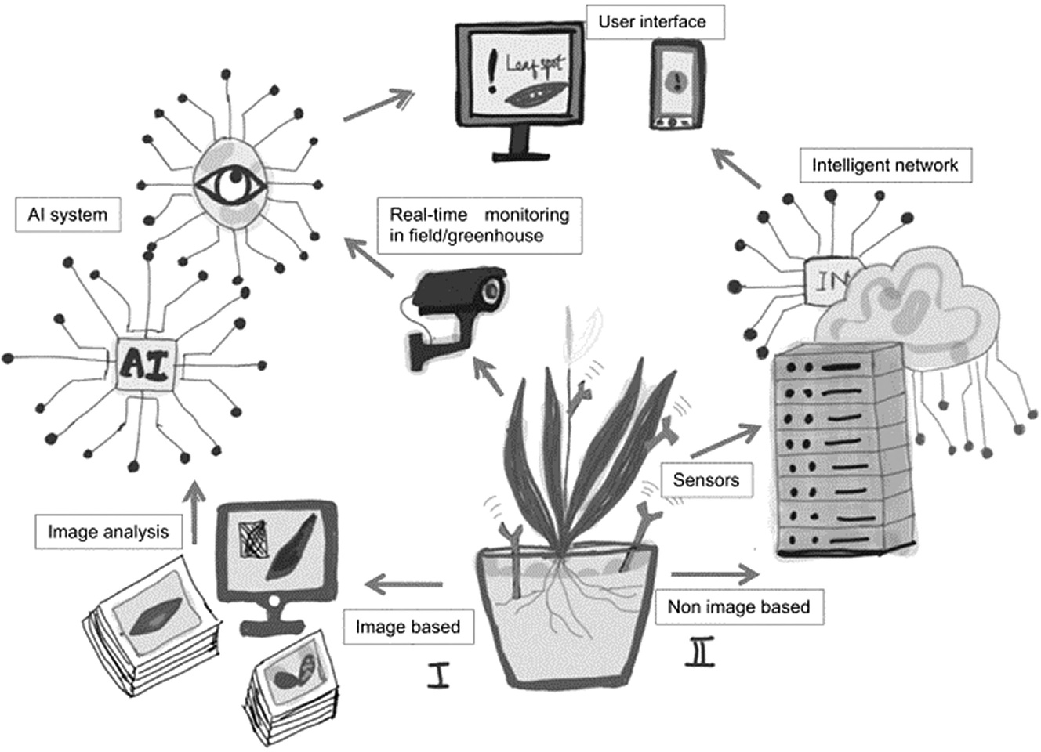

FIGURE 13.7
Significance of neural networks in crop disease detection.

employed deep-learning models to detect multiple diseases across different crop species, including tomatoes, soybeans, and grapes. The adaptability of neural networks makes them valuable tools for diverse agricultural settings.
- Data-Driven Decision-Making: Neural networks facilitate data- driven decision-making for farmers. By analysing historical data on crop health and environmental conditions, neural networks can pro- vide insights into optimal planting times, irrigation schedules, and disease management strategies, ultimately improving crop yield and resource utilisation.
- Reduced Environmental Impact: Neural network–driven precision agriculture can lead to reduced environmental impact. By optimis- ing resource usage, such as water, pesticides, and fertilisers, these systems contribute to more sustainable farming practices, aligning with the global goal of reducing agriculture’s ecological footprint.

Neural networks have demonstrated their significance in crop detection through previous research examples by enhancing accuracy, enabling early disease detection, supporting precision agriculture, automating

monitoring, adapting to diverse crops, facilitating data-driven decision- making, and promoting environmentally sustainable practices. These advancements have the potential to improve crop yields, food security, and the sustainability of agriculture in a world facing increasing challenges. Moreover, here we are providing the step-by-step algorithm to detect the disease in the crops in Table 13.1.

TABLE 13.1
Algorithm for Crop Disease Detection
A Step-By-Step Process for Crop Disease Detection Using Neural Networks

- Data Collection:
  - Gather a dataset of images containing healthy crops and crops affected by various diseases. The dataset should be diverse, representative, and labelled accurately.
- Data Preprocessing:
  - Resize and standardise the images to a uniform size.
  - Increase the quantity and variety of the dataset by adding changes like rotation, flipping, and brightness tweaks.
  - Split the dataset into training, validation, and testing sets (typically, 70%–80% for training, 10%–15% for validation, and 10%–15% for testing).
- Building the Neural Network:
  - Select a neural network design that is appropriate for classifying images. Commonly used for this purpose are CNNs.
  - Design the architecture with an input layer, multiple convolutional layers, pooling layers, and fully connected layers.
  - Use activation functions like the Rectified Linear Unit (ReLU), and consider using dropout layers to prevent overfitting.
  - Select an appropriate loss function, such as categorical cross-entropy, and an optimisation algorithm like Adam.
- Model Training:
  - Feed the training data into the neural network and start training the model.
  - Monitor training metrics (e.g., loss and accuracy) on both the training and validation datasets.
  - Implement early stopping to prevent overfitting.
- Hyperparameter Tuning:
  - Experiment with different hyperparameters – for example, batch size, learning rate, and network architecture.
  - Use techniques like grid search or random search to find the best hyperparameters.
- Evaluation:
  - After training, evaluate the model’s performance on the test dataset.
  - Calculate metrics such as accuracy, precision, recall, F1-score, and confusion matrix to assess its effectiveness in disease detection.

(Continued)

TABLE 13.1 (CONTINUED)

A Step-By-Step Process for Crop Disease Detection Using Neural Networks

- Model Fine-Tuning:
  - If the initial results are not satisfactory, fine-tune the model by adjusting hyperparameters or modifying the architecture.
- Interpretability:
  - Consider techniques for model interpretability, such as visualisation of feature maps to understand which parts of the images the model is focusing on for disease detection.
- Deployment:
  - Once you are satisfied with the model’s performance, deploy it in the field.
  - Create a user-friendly interface for farmers or agricultural experts to upload images for disease diagnosis.
  - Ensure that the deployed model can handle new and unseen data effectively.
- Continuous Monitoring and Updates:
  - Regularly assess how the deployed model is doing and change it as necessary with fresh information or enhanced algorithms.
  - Stay informed about new developments in crop disease detection and neural networks to keep your solution up-to-date.

ROLE OF NEURAL NETWORK IN CROP DISEASE DETECTION
Neural networks provide a strong and adaptable method for automating the diagnosis and treatment of plant illnesses, which is a major contribu- tion to agricultural disease detection. The following highlights how neural networks help to handle this important agricultural challenge:

- Accurate Disease Identification: Neural networks, particularly CNNs, are excellent at jobs requiring visual identification. CNNs can reliably detect the presence of illnesses in agricultural samples by analysing photos of affiicted plants. They gain the ability to see irregularities and delicate visual patterns in fruit, stems, and leaf tis- sue that may be difficult for the human eye to notice.
- Early Detection: Neural networks are capable of enabling early dis- ease detection, allowing farmers to take prompt action to stop the spread of illnesses. Farmers may stop illnesses in their early stages, minimising crop losses, by routinely scanning fields with cameras

or drones fitted with disease detection algorithms based on neural networks.
- High-Throughput Screening: Neural networks can quickly analyse enormous amounts of pictures, making it feasible to screen crops in a high-throughput manner. The efficient and economical monitor- ing of large agricultural fields depends on this skill.
- Precision Agriculture: By assisting farmers in more accurate dis- ease control efforts, neural networks allow precision agriculture. Farmers may utilise neural network insights to administer interven- tions just where they are required, decreasing the usage of chemicals and their negative effects on the environment. This is an alternative to uniformly spraying pesticides or treatments over whole fields.
- Remote Sensing: Neural networks may be used with remote sensing technology, such as drones or satellites, to monitor crops over wide geographic regions. In areas where access to agricultural profession- als is scarce, this remote monitoring offers useful information for disease identification and control.
- Continuous Learning: As disease patterns evolve, neural networks may be taught and retrained using new data. Because of their adapt- ability, illness detection algorithms may continually learn and become better over time, which raises the accuracy and efficiency of their results.
- Data Analytics: Neural networks may be used as part of a wider data analytics pipeline that incorporates information from a variety of sources, including weather, soil quality, and past disease trends. Farmers may get a thorough understanding of disease risks and via- ble prevention measures from this all-inclusive approach.
- Scaling Knowledge: Neural networks offer the ability to scale knowl- edge and skill in illness diagnosis. Advanced agricultural technol- ogy may now be more widely available because of the sharing and deployment of models that have been trained on expert data.
- Reduced Labour Costs: Neural networks may eliminate the need for manual labour in crop inspection and disease diagnosis, saving time and money for farmers.

The precise, effective, and scalable solutions offered by neural networks have revolutionised agricultural disease detection. They enable farmers and other agricultural stakeholders to make data-driven choices, reduce crop losses, and promote the growth of healthier and more productive crops, all of

which improve global food security. A substantial advancement in efficient and sustainable agriculture may be seen in this technique.

CONCLUSION
The chapter on the role of neural networks in crop disease detection has, in summary, shed light on a critical future direction for contemporary agriculture. It is impossible to overstate the importance of crop diseases as a worldwide threat to food security, and the use of neural networks for disease detection is a glimmer of hope. With its extraordinary ability for picture recognition, sequence analysis, and data-driven decision-making, neural networks have proved to be very useful tools for both academics and farmers. We have explored the complexities of neural network designs through the lens of this chapter, marvelling at their remarkable capacity to quickly and reliably detect crop illnesses, often in their early stages. The effectiveness of CNNs in image-based detection, the context aware- ness of RNNs in sequential data processing, and the potential for con- tinuous learning and adaptation in the always-changing fight against crop diseases have all been examined. A new age of precision agriculture has also been ushered in thanks to the convergence of neural networks with cutting-edge technology like remote sensing, drones, and data analytics.
This integration enables the exact implementation of therapies, lowering the environmental effect and increasing resource efficiency, in addition to the early and accurate detection of disorders. The use of neural networks in agricultural disease detection is expected to continue to develop in the future. Technology and knowledge will continue to become more acces- sible, giving farmers all across the globe access to these effective tools and improving global food security. The chapter has emphasised the enormous potential for scientists, agricultural specialists, and technology to work together in order to push the limits of what is feasible in order to protect our crops and ensure a sustainable and resilient future. They open a new chapter in the history of agriculture, one that is characterised by innova- tion, empowerment, and optimism. They represent more than simply a chapter in the annals of crop disease detection. This chapter gives us hope for the future because it shows how far neural networks have come and how well-equipped we are to safeguard our crops, feed our people, and create a wealthier and sustainable world.

REFERENCES
- https://www.edrawsoft.com/article/neural-network-diagram.html
- https://dataaspirant.com/how-recurrent-neural-network-rnn-works/
- https://modeling-languages.com/lstm-neural-network-model-transformations/
- https://medium.com/fnplus/what-is-all-about-generative-adversarial-networks- gans-33faa7b78363
- Shahi, T. B., Xu, C. Y., Neupane, A., & Guo, W. (2023). Recent Advances in Crop Disease Detection Using UAV and Deep Learning Techniques. Remote Sensing, 15(9), 2450.
- Putra, O. V., Trisnaningrum, N., Puspitasari, N. S., Wibowo, A. T., & Rachmawaty,
E. (2022, August). An Optimized Rice Leaf Disease Classification Using Transfer Learning and Balanced Class Weight Distribution based on Bandit Approach. In 2022 5th International Conference on Information and Communications Technology (ICOIACT) (pp. 417–422). IEEE.
- Jain, S., & Ramesh, D. (2021, July). AI Based Hybrid CNN-LSTM Model for Crop Disease Prediction: An ML Advent for Rice Crop. In 2021 12th International Conference on Computing Communication and Networking Technologies (ICCCNT) (pp. 1–7). IEEE.
- Fenu, G., & Malloci, F. M. (2021). Forecasting Plant and Crop Disease: An Explorative Study on Current Algorithms. Big Data and Cognitive Computing, 5(1), 2.
- Annabel, L. S. P., & Muthulakshmi, V. (2019, December). AI-Powered Image-Based Tomato Leaf Disease Detection. In 2019 Third International Conference on I-SMAC (IoT in Social, Mobile, Analytics and Cloud) (I-SMAC) (pp. 506–511). IEEE.
- Zhong, Y., & Zhao, M. (2020). Research on Deep Learning in Apple Leaf Disease Recognition. Computers and Electronics in Agriculture, 168, 105146.
- Ahsan, T., Khan, M., Ahmed, M., Zafar, T., & Javeed, A. (2022). Applications of Artificial Intelligence in Crop Disease Diagnose and Management. International Journal of Scientific Engineering and Research, 13, 1000–1015.

